310252 Web Technology

Prerequisites Courses:

Companion Course: Database Management Systems (310241),Computer Networks (317521)

Course Objectives:

- To learn the fundamentals of web essentials and markup languages
- To use the Client side technologies in web development
- To use the Server side technologies in web development
- To understand the web services and frameworks

Course Outcomes:
On completion of the course, learners should be able to:

On completion of the course, learners should be able to
CO1: Implement and analyze behavior of web pages using HTML and CSS
CO2: Apply the client side technologies for web development
CO3: Analyze the concepts of Servlet and JSP
CO4: Analyze the Web services and frameworks
CO5: Apply the server side technologies for web development
CO6: Create the effective web applications for business functionalities using latest web development platforms

Unit I
Web Essentials and Mark-up language - HTML 07 Hours
The Internet, basic internet protocols, the World Wide Web, HTTP Request message, HTTP response message, web clients, web servers.HTML: Introduction, history and versions.HTML elements: headings, paragraphs, line break, colors and fonts, links, frames, lists, tables, images and forms, Difference between HTML and HTML5. CSS: Introduction to Style Sheet, CSS features, CSS core syntax, Style sheets and HTML, Style rule cascading and inheritance, text properties. Bootstrap.

The Internet
The Internet is a vast network that connects computers all over the world. Through the Internet, people can share information and communicate from anywhere with an Internet connection.

The Internet traces its roots to a project of the U.S. Department of Defense’s then- named Advanced Research Projects Agency, or ARPA. The ARPANET project was intended to support DoD research on computer networking. As this project began in the late 1960s, there had been only a few small experimental networks providing communication between geographically dispersed computers from different manufacturers running different operating systems.

Several of the most widely used Internet protocols— including the File Transfer Protocol (FTP) and Simple Mail Transfer Protocol (SMTP), which underlie many of the Internet’s file transfer and e-mail operations, respectively— were initially developed under ARPANET.

ARPANET switched from using an earlier protocol to TCP/IP during 1982. At around the same time, an ARPA Internet was created, allowing computers on some outside networks such as CSNET to communicate via TCP/ IP with computers on the ARPANET.

Access to the ARPANET was expanded in 1981 when the National Science Foundation (NSF) funded the Computer Science Network (CSNET). In 1982, the Internet Protocol Suite (TCP/IP) was standardized, which permitted worldwide proliferation of interconnected networks. TCP/IP network access expanded again in 1986 when the National Science Foundation Network (NSFNet) provided access to supercomputer sites in the United States for researchers, first at speeds of 56 kbit/s and later at 1.5 Mbit/s and 45 Mbit/s.

The NSFNet expanded into academic and research organizations in Europe, Australia, New Zealand and Japan in 1988–89. Although other network protocols such as UUCP had global reach well before this time, this marked the beginning of the Internet as an intercontinental network. Commercial Internet service providers (ISPs) emerged in 1989 in the United States and Australia. The ARPANET was decommissioned in 1990.

In summary, the Internet is the collection of computers that can communicate with one another using TCP/IP over an open, global communications network.

Basic Internet Protocols
A computer communication protocol is a detailed specification of how communication between two computers will be carried out in order to serve some purpose.

TCP/IP
TCP is a connection oriented protocol and offers end-to-end packet delivery. It acts as back bone for connection.It exhibits the following key features:
- Transmission Control Protocol (TCP) corresponds to the Transport Layer of OSI Model.
- TCP is a reliable and connection oriented protocol.
- TCP offers:
  - Stream Data Transfer.
  - Reliability.
  - Efficient Flow Control
  - Full-duplex operation.
  - Multiplexing.
- TCP offers connection oriented end-to-end packet delivery.
- TCP ensures reliability by sequencing bytes with a forwarding acknowledgement number that indicates to the destination the next byte the source expects to receive.
- It retransmits the bytes not acknowledged within the specified time period.

IP address
A key element of IP is the IP address, which is simply a 32-bit number. At any given moment, each device on the Internet has one or more IP addresses associated with it (although the device associated with a given address may change over time). IP ad- dresses are normally written as a sequence of four decimal numbers separated by periods (called “dots”), as in 192.0.34.166. Each decimal number represents one byte of the IP address. The function of IP software is to transfer data from one computer (the source) to another computer (the destination).

Packet
In telecommunications and computer networking, a network packet is a formatted unit of data carried by a packet-switched network. A packet consists of control information and user data; the latter is also known as the payload. Control information provides data for delivering the payload (e.g., source and destination network addresses, error detection codes, or sequencing information). Typically, control information is found in packet headers and trailers.

Gateway
A gateway is a piece of networking hardware or software used in telecommunications networks that allows data to flow from one discrete network to another.

Hops
In wired computer networking, including the Internet, a hop occurs when a packet is passed from one network segment to the next. Data packets pass through routers as they travel between source and destination. The hop count refers to the number of network devices through which data passes from source to destination.

Route
The sequence of computers that a packet travels through from source to destination is known as its route.

Checksum
IP software also adds some error detection information (a checksum) to each packet it creates, so that if a packet is corrupted during transmission, this can usually be detected by the recipient. The IP standard calls for IP software to simply discard any corrupted packets.

Acknowledgement
Once a connection has been established, TCP provides reliable data transmission by demanding an acknowledgment for each packet it sends via IP. Essentially, the software sets a timer after sending each packet. The TCP software on the receiving side sends a packet containing an acknowledgment for every TCP- based packet it receives that passes the checksum test. If the TCP software sending a packet does not receive an acknowledgment packet before its timer expires, then it resends the packet and restarts the timer.

Port
The port concept allows TCP to be used to communicate with many different applications on a machine. For example, a machine connected to the Internet may run a mail server for users on its local network, a file download server, and also a server that allows users to log in to the machine and execute commands from remote locations.

UDP, DNS and Domain Names

UDP - User Datagram Protocol

User Datagram Protocol (UDP) is a Transport Layer protocol. UDP is a part of the Internet Protocol suite, referred to as UDP/IP suite. Unlike TCP, it is an unreliable and connectionless protocol. So, there is no need to establish a connection prior to data transfer.

Though Transmission Control Protocol (TCP) is the dominant transport layer protocol used with most of the Internet services, it provides assured delivery, reliability, and much more but all these services cost us additional overhead and latency. Here, UDP comes into the picture. For real-time services like computer gaming, voice or video communication, live conferences; we need UDP. Since high performance is needed, UDP permits packets to be dropped instead of processing delayed packets. There is no error checking in UDP, so it also saves bandwidth. User Datagram Protocol (UDP) is more efficient in terms of both latency and bandwidth.

UDP Header
UDP header is an 8-byte fixed and simple header, while for TCP it may vary from 20 bytes to 60 bytes. The first 8 Bytes contain all necessary header information and the remaining part consist of data. UDP port number fields are each 16 bits long, therefore the range for port numbers is defined from 0 to 65535; port number 0 is reserved. Port numbers help to distinguish different user requests or processes.
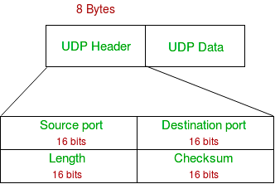

      - Source Port: Source Port is a 2 Byte long field used to identify the port number of the source.
      - Destination Port: It is a 2 Byte long field, used to identify the port of the destined packet.
      - Length: Length is the length of UDP including the header and the data. It is a 16-bits field.
      - Checksum: Checksum is 2 Bytes long field. It is the 16-bit one’s complement of the one’s complement sum of the UDP header, the pseudo-header of information from the IP header, and the data, padded with zero octets at the end (if necessary) to make a multiple of two octets.

Domain Name System
The Domain Name System (DNS) is the hierarchical and decentralized naming system used to identify computers, services, and other resources reachable through the Internet or other Internet Protocol (IP) networks. The resource records contained in the DNS associate domain names with other forms of information. These are most commonly used to map human-friendly domain names to the numerical IP addresses computers need to locate services and devices using the underlying network protocols, but have been extended over time to perform many other functions as well. The Domain Name System has been an essential component of the functionality of the Internet since 1985.

Domain Names
A domain name is an identification string that defines a realm of administrative autonomy, authority or control within the Internet. Domain names are used in various networking contexts and for application-specific naming and addressing purposes.

World Wide Web
The World Wide Web (WWW), commonly known as the Web, is an information system where documents and other web resources are identified by Uniform Resource Locators (URLs, such as https://example.com/), which may be interlinked by hyperlinks, and are accessible over the Internet. The resources of the Web are transferred via the Hypertext Transfer Protocol (HTTP), may be accessed by users by a software application called a web browser, and are published by a software application called a web server. The World Wide Web is not synonymous with the Internet, which predated the Web in some form by over two decades and upon the technologies of which the Web is built.

Hypertext Transport Protocol
The Hypertext Transfer Protocol (HTTP) is an application layer protocol in the Internet protocol suite model for distributed, collaborative, hypermedia information systems. HTTP is the foundation of data communication for the World Wide Web, where hypertext documents include hyperlinks to other resources that the user can easily access, for example by a mouse click or by tapping the screen in a web browser.

HTTP Request Message
    - OverallStructure
Every HTTP request message has the same basic structure:

Start line
Header field(s) (one or more)
Blank line
Message body (optional)

HTTP Version
HTTP/1.0 a separate connection to the same server is made for every resource request

HTTP/1.1 instead a TCP connection can be reused to make multiple resource requests (i.e. of HTML pages, frames, images, scripts, stylesheets, etc.)

HTTP/2 is a revision of previous HTTP/1.1 in order to maintain the same client-server model and the same protocol methods but with these differences in order: to use a compressed binary representation of metadata (HTTP headers) instead of a textual one, so that headers require much less space;

HTTP/3 is a revision of previous HTTP/2 in order to use QUIC + UDP transport protocols instead of TCP/IP connections also to slightly improve the average speed of communications and to avoid the occasional (very rare) problem of TCP/IP connection congestion that can temporarily block or slow down the data flow of all its streams (another form of "head of line blocking”).

Request-URI
The second part of the start line is known as the Request-URI. The concatenation of the string http://, the value of the Host header field (www.example.org, in this example), and the Request-URI (/ in this example) forms a string known as a Uniform Resource Identifier (URI). A URI is an identifier that is intended to be associated with a particular resource (such as a web page or graphics image) on the World Wide Web. Every URI consists of two parts: the scheme, which appears before the colon (:), and another part that depends on the scheme. Web addresses, for the most part, use the http scheme (the scheme name in URIs is case insensitive, but is generally written in lowercase letters). In this scheme, the URI represents the location of a resource on the Web. A URI of this type is said to be a Uniform Resource Locator (URL). Therefore, URIs using the http scheme are both URIs and URLs.
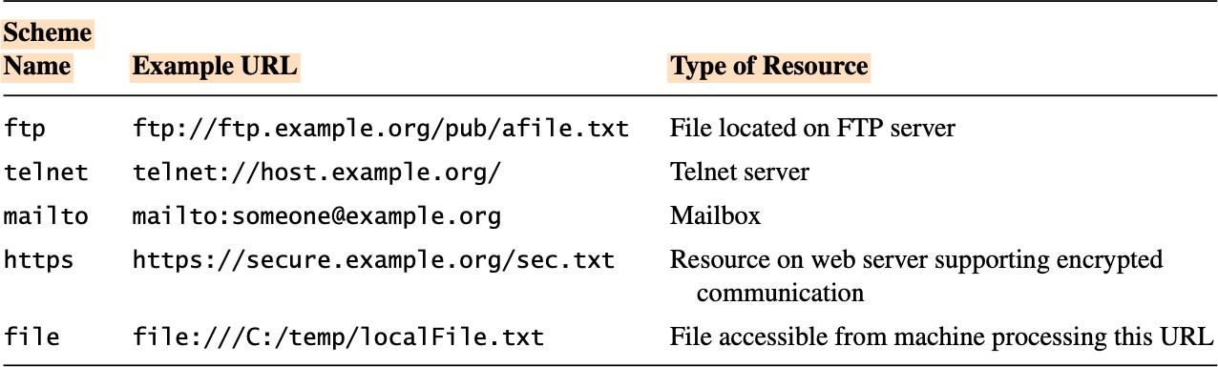

RequestMethod
- GET
The GET method is used to retrieve information from the given server using a given URI. Requests using GET should only retrieve data and should have no other effect on the data.

- HEAD
Same as GET, but transfers the status line and header section only.

- POST
A POST request is used to send data to the server, for example, customer information, file upload, etc. using HTML forms.

- PUT
Replaces all current representations of the target resource with the uploaded content.

- DELETE
Removes all current representations of the target resource given by a URI.

- CONNECT
Establishes a tunnel to the server identified by a given URI.

- OPTIONS
Describes the communication options for the target resource.

- TRACE
Performs a message loop-back test along the path to the target resource.

Header Fields and MIME Types
The Host header field is required in every HTTP/1.1 request message. HTTP/1.1 also defines a number of other header fields, several of which are commonly used by modern browsers. Each header field begins with a field name, such as Host, followed by a colon and then a field value.

POST /servlet/EchoHttpRequest HTTP/1.1
host: www.example.org:56789
user-agent: Mozilla/5.0 (Windows; U; Windows NT 5.1; en-US; rv:1.4)
Gecko/20030624
accept: text/xml,application/xml,application/xhtml+xml,
text/html;q=0.9,text/plain;q=0.8,video/x-mng,image/png,image/jpeg,
image/gif;q=0.2,*/*;q=0.1
accept-language: en-us,en;q=0.5
accept-encoding: gzip,deflate
accept-charset: ISO-8859-1,utf-8;q=0.7,*;q=0.7
connection: keep-alive
keep-alive: 300
content-type: application/x-www-form-urlencoded
content-length: 13

A next common feature is the use of so-called MIME types in several header field values. MIME is an acronym standing for Multipurpose Internet Mail Extensions, and refers to a standard that can be used to pass a variety of types of information, including graphics and applications, through e-mail as well as through other Internet message protocols.
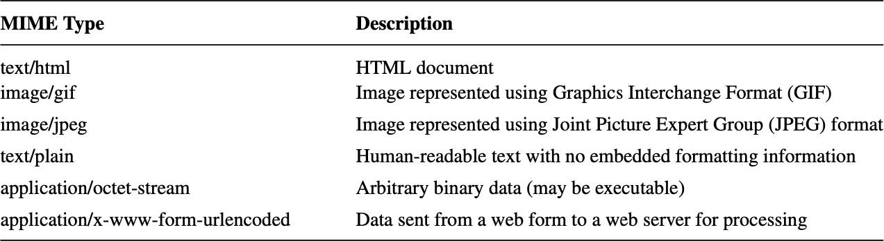

HTTP Response Message
HTTP response message consists of a status line, header fields, and the body of the response, in the following format:

Status line
Header field(s) (one or more)
Blank line
Message body (optional)

Response Status Line
This is a list of Hypertext Transfer Protocol (HTTP) response status codes. Status codes are issued by a server in response to a client's request made to the server. It includes codes from IETF Request for Comments (RFCs), other specifications, and some additional codes used in some common applications of the HTTP. The first digit of the status code specifies one of five standard classes of responses.

All HTTP response status codes are separated into five classes or categories. The first digit of the status code defines the class of response, while the last two digits do not have any classifying or categorization role. There are five classes defined by the standard:

- 1xx informational response – the request was received, continuing process
- 2xx successful – the request was successfully received, understood, and accepted
- 3xx redirection – further action needs to be taken in order to complete the request
- 4xx client error – the request contains bad syntax or cannot be fulfilled
- 5xx server error – the server failed to fulfil an apparently valid request

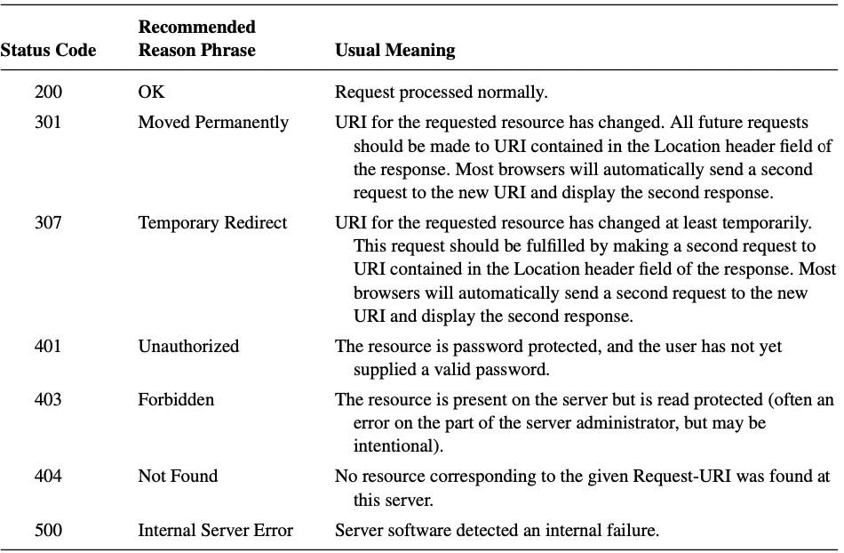
Response Header Fields

    - Cache Control
Cache-control is an HTTP header used to specify browser caching policies in both client requests and server responses. Policies include how a resource is cached, where it’s cached and its maximum age before expiring.

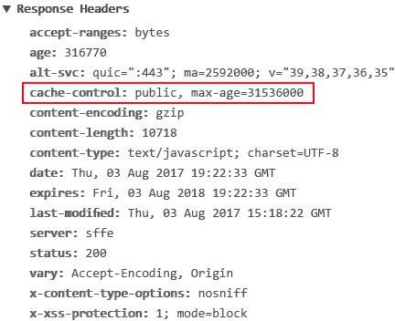

Character Sets
A character set defines the mapping between these integers, or code points, and characters. For example, US-ASCII [RFC-1345] is the character set used to represent the characters used in HTTP header field names, and is also used in key portions of many other Internet protocols.

Web Clients

A web client is software that accesses a web server by sending an HTTP request message and processing the resulting HTTP response. Web browsers running on desktop or laptop computers are the most common form of web client software,

User Agent
In general, any web client that is designed to directly support user access to web servers is known as a user agent.
Basic Browser Functions
Bars
The window of a typical modern browser is split into several rectangular regions, most of which are known as bars.

Client Area
The primary region is the client area, which displays a document.

Title Bar
The title bar displays a title assigned by the document author to the document currently displayed within the client area.

Menu Bar
The menu bar contains a set of dropdown menus, much like most other applications that incorporate a graphical user interface (GUI).

Location Bar
The Navigation toolbar also contains a text box, known as the Location bar, where a user can enter a URL and press the Enter key in order to request the browser to display the document located at the specified URL.
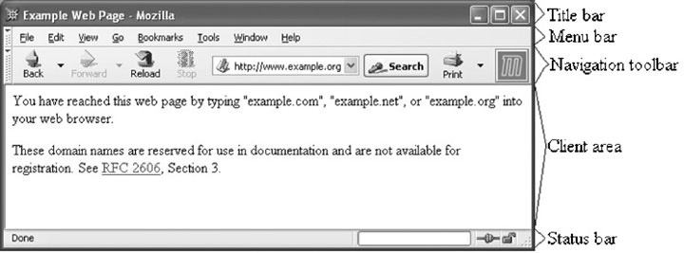

Web Servers
A web server is computer software and underlying hardware that accepts requests via HTTP or its secure variant HTTPS.

Server Features
- Receive HTTP request via TCP
- Map Host header to specific virtual host (one of many hostnames sharing an IP address)
- Map Request-URI to specific resource associated with the virtual host
- File: Return file in HTTP response
- Program: Run program and return output in HTTP response
- Map type of resource to appropriate MIME type and use to set Content-Type header in HTTP response
- Log information about the request and response.

HTML
HTML stands for Hyper Text Markup Language, which is the most widely used language on the Web to develop web pages. HTML was created by Berners-Lee in late 1991 but "HTML 2.0" was the first standard HTML specification which was published in 1995. HTML 4.01 was a major version of HTML and it was published in late 1999. Though the HTML 4.01 version is widely used, currently we are having the HTML-5 version.

HTML Introduction
HTML is the standard markup language for creating Web pages.

Code | Output
<!DOCTYPE html>  <html>  <head>  <title>This is document title</ title>  </head>  <body>  <h1>This is a heading</h1>  <p>Hello World!</p>  </body>  </html> | This is a heading  Hello World!

Applications of HTML
As mentioned before, HTML is one of the most widely used language over the web. Following are few of them here:
- Web pages development - HTML is used to create pages which are rendered over the web. Almost every page of the web has html tags in it to render its details in the browser.
- Internet Navigation - HTML provides tags which are used to navigate from one page to another and is heavily used in internet navigation.
- Responsive UI - HTML pages now-a-days works well on all platforms, mobile, tabs, desktop or laptops owing to responsive design strategy.
- Offline support HTML pages once loaded can be made available offline on the machine without any need of the internet.

HTML History
HTML was created by Sir Tim Berners-Lee in late 1991 but was not released officially, published in 1995 as HTML 2.0. HTML 4.01 was published in late 1999 and was a major version of HTML.

HTML Versions.
- HTML 1.0 was released in 1993 with the intention of sharing information that can be readable and accessible via web browsers. But not many of the developers were involved in creating websites. So the language was also not growing.
- Then comes the HTML 2.0, published in 1995, which contains all the features of HTML 1.0 along with that few additional features, which remained as the standard markup language for designing and creating websites until January 1997 and refined various core features of HTML.
- Then comes HTML 3.0, where Dave Raggett introduced a fresh paper or draft on HTML. It included improved new features of HTML, giving more powerful characteristics for webmasters in designing web pages. But these powerful features of new HTML slowed down the browser in applying further improvements.
- Then comes HTML 4.01, which is widely used and was a successful version of HTML before HTML 5.0, which is currently released and used worldwide. HTML 5 can be said for an extended version of HTML 4.01.

HTML Elements
An HTML element is defined by a start tag, some content, and an end tag. The HTML element is everything from the start tag to the end tag:

<tagname>Content goes here...</tagname>

<h1>My First Heading</h1>
<p>My first paragraph.</p>

Start tag | Element content | End tag
<h1> | My First Heading | </h1>
<p> | My first paragraph. | </p>
<br> | none | none

Nested HTML Elements
<!DOCTYPE html>
<html>
<body>

<h1>My First Heading</h1>
<p>My first paragraph.</p>

</body>
</html>

HTML Headings
HTML headings are titles or subtitles that you want to display on a webpage. HTML headings are defined with the <h1> to <h6> tags. <h1> defines the most important heading. <h6> defines the least important heading.

Code | Output
<!DOCTYPE html>  <html>  <body>  <h1>Heading 1</h1>  <h2>Heading 2</h2>  <h3>Heading 3</h3>  <h4>Heading 4</h4>  <h5>Heading 5</h5>  <h6>Heading 6</h6>  </body>  </html> | Heading 1  Heading 2  Heading 3  Heading 4  Heading 5  Heading 6

Paragraphs
A paragraph always starts on a new line, and is usually a block of text. The HTML <p> element defines a paragraph. A paragraph always starts on a new line, and browsers automatically add some white space (a margin) before and after a paragraph.

Code | Output
<!DOCTYPE html>  <html>  <body>  <p>This is a paragraph.</p>  <p>This is a paragraph.</p>  <p>This is a paragraph.</p>  </body>  </html> | This is a paragraph.  This is a paragraph.  This is a paragraph

Line Break
Insert single line breaks in a text:

<!DOCTYPE html>  <html>  <body>  <h1>The br element</h1>  <p>To force<br> line breaks<br> in a text,<br> use the br<br> element.</p>  </body>  </html> | The br element  To force  line breaks  in a text,  use the br  element.

Colors
HTML colors are specified with predefined color names, or with RGB, HEX, HSL, RGBA, or HSLA values.

There are following three different methods to set colors in your web page −
- Color names − You can specify color names directly like green, blue or red.
- Hex codes − A six-digit code representing the amount of red, green, and blue that makes up the color.
- Color decimal or percentage values − This value is specified using the rgb( ) property.

Code | Output
<!DOCTYPE html>  <html>  <body>  <p>Same as color name "Tomato":</p>  <h1 style="background-color:rgb(255, 99, 71);" >rgb(255, 99, 71)</h1>  <h1 style="background-color:#ff6347;">#ff6347</h1>  <h1 style="background-color:hsl(9, 100%, 64%);" >hsl(9, 100%, 64%)</h1>  <p>Same as color name "Tomato", but 50% transparent:</p>  <h1 style="background-color:rgba(255, 99, 71, 0.5);" >rgba(255, 99, 71, 0.5)</h1>  <h1 style="background-color:hsla(9, 100%, 64%, 0.5);" >hsla(9, 100%, 64%, 0.5)</h1>  <p>In addition to the predefined color names, colors can be specified using RGB, HEX, HSL, or even transparent colors using RGBA or HSLA color values.</p>  </body>  </html> | 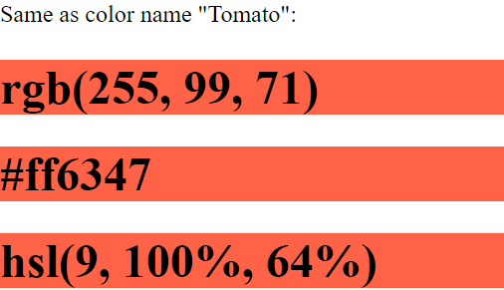  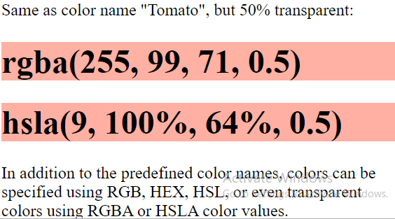

Fonts
The <font> tag was used in HTML 4 to specify the font face, font size, and color of text.

Code | Output
<!DOCTYPE html>  <html>  <body>  <p style="font-size:30px">This is a paragraph. </p>  <p style="font-size:11px">This is another paragraph.</p>  </body>  </html> | This is a paragraph.  This is another paragraph.

Links
The HTML <a> tag defines a hyperlink. It has the following syntax:
<a href="url">link text</a>
The most important attribute of the <a> element is the href attribute, which indicates the link's destination. The link text is the part that will be visible to the reader.
Clicking on the link text, will send the reader to the specified URL address.

Code | Output
<!DOCTYPE html>  <html>  <body> | HTML Links
<h1>HTML Links</h1> | Visit Google website!
<p><a href="https:// www.google.com"> Visit Google website!</a></p>
</body>
</html>

Frames
The <frame> tag was used in HTML 4 to define one particular window (frame) within a <frameset>.
Use the <iframe> tag to embed another document within the current HTML document.

<!DOCTYPE html>  <html>  <body>  <h1>The iframe element</h1>  <iframe src="https://www.bing.com" title="bing.com">  </iframe>  </body>  </html> | 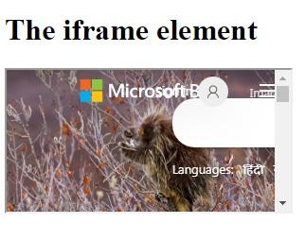

List
- HTML lists allow web developers to group a set of related items in lists.
- An unordered list starts with the <ul> tag.
- An ordered list starts with the <ol> tag. Each list item starts with the <li> tag.
- A description list is a list of terms, with a description of each term.
- The <dl> tag defines the description list, the <dt> tag defines the term (name), and the <dd> tag describes each term

Code | Output
<!DOCTYPE html>  <html>  <body>  <h2>An Unordered HTML List</h2>  <ul>  <li>Coffee</li>  <li>Tea</li>  <li>Milk</li>  </ul>  <h2>An Ordered HTML List</h2>  <ol>  <li>Coffee</li>  <li>Tea</li>  <li>Milk</li>  </ol>  </body>  </html> | An Unordered HTML List  - Coﬀee  - Tea  - Milk  An Ordered HTML List  - Coﬀee  - Tea  - Milk

Code | Output
<!DOCTYPE html>  <html>  <body>  <h2>A Description List</h2>  <dl>  <dt>Coffee</dt>  <dd>- black hot drink</dd>  <dt>Milk</dt>  <dd>- white cold drink</dd>  </dl>  </body>  </html> | A Description List  Coffee  - black hot drink  Milk  - white cold drink

Tables

HTML tables allow web developers to arrange data into rows and columns.

Code | Output
<!DOCTYPE html>  <html>  <head>  <title>HTML Table Header</title>  </head>  <body>  <table border = "1">  <tr>  <th>Name</th>  <th>Salary</th>  </tr>  <tr>  <td>Ramesh Raman</td>  <td>5000</td>  </tr>  <tr>  <td>Shabbir Hussein</td>  <td>7000</td>  </tr>  </table>  </body>  </html> | 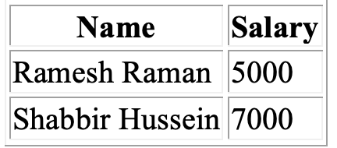

HTML tables can have cells that span over multiple rows and/or columns.
To make a cell span over multiple columns, use the colspan attribute:

Code | Output
<!DOCTYPE html>  <html>  <head>  <style>  table, th, td {  border: 1px solid black;  border-collapse: collapse;  }  </style>  </head>  <body>  <h2>Cell that spans two columns</h2>  <p>To make a cell span more than one column, use the colspan attribute.</p>  <table style="width:100%">  <tr>  <th colspan="2">Name</th>  <th>Age</th>  </tr>  <tr>  <td>Jill</td>  <td>Smith</td>  <td>43</td>  </tr>  <tr>  <td>Eve</td>  <td>Jackson</td>  <td>57</td>  </tr>  </table>  </body>  </html> | 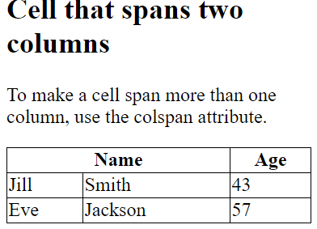

To make a cell span over multiple rows, use the rowspan attribute:

Code | Output
<!DOCTYPE html>  <html>  <head>  <style>  table, th, td {  border: 1px solid black;  border-collapse: collapse;  }  </style>  </head>  <body>  <h2>Cell that spans two rows</h2>  <p>To make a cell span more than one row, use the rowspan attribute.</p>  <table style="width:100%">  <tr>  <th>Name</th>  <td>Jill</td>  </tr>  <tr>  <th rowspan="2">Phone</th>  <td>555-1234</td>  </tr>  <tr>  <td>555-8745</td>  </tr>  </table>  </body>  </html> | 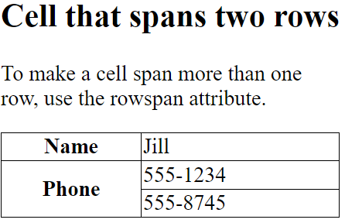

Images
The HTML <img> tag is used to embed an image in a web page.
Images are not technically inserted into a web page; images are linked to web pages. The <img> tag creates a holding space for the referenced image.
The <img> tag is empty, it contains attributes only, and does not have a closing tag. The <img> tag has two required attributes:
- src - Specifies the path to the image
- alt - Specifies an alternate text for the image

Code | Output

<!DOCTYPE html>  <html>  <body>  <h2>Alternative text</h2>  <p>The alt attribute should reflect the image content, so users who cannot see the image gets an understanding of what the image contains:</p>  <img src="img_chania.jpg" alt="Flowers in Chania" width="460" height="345">  </body>  </html> | 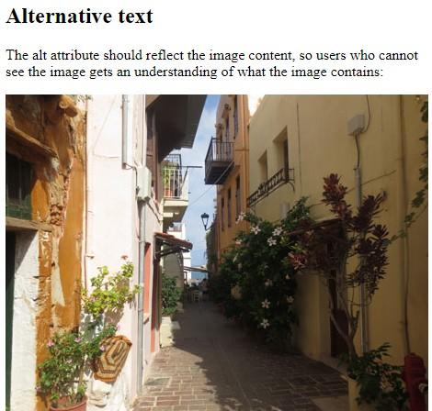

Forms
- An HTML form is used to collect user input.
- The user input is most often sent to a server for processing.
- The HTML <form> element is used to create an HTML form for user input.
- The <form> element is a container for different types of input elements, such as: text fields, checkboxes, radio buttons, submit buttons, etc.
- The HTML <input> element is the most used form element.
- An <input> element can be displayed in many ways, depending on the type attribute.
- Here are some examples:
Type | Description
<input type="text"> | Displays a single-line text input field.
<input type="radio"> | Displays a radio button (for selecting one of many choices)
<input type="checkbox"> | Displays a checkbox (for selecting zero or more of many choices)
<input type="submit"> | Displays a submit button (for submitting the form)
<input type="button"> | Displays a clickable button

Code | Output
<!DOCTYPE html>  <html>  <body>  <h2>HTML Forms</h2>  <form action="/action_page.php">  <label for="fname">First name:</label><br>  <input type="text" id="fname" name="fname" value="John"><br>  <label for="lname">Last name:</label><br>  <input type="text" id="lname" name="lname" value="Blesswin"><br><br>  <input type="submit" value="Submit">  </form>  </body>  </html> | 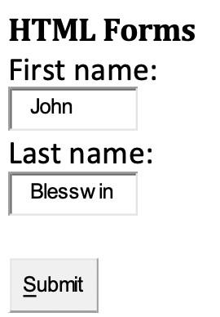

CSS
Cascading Style Sheets, fondly referred to as CSS, is a simple design language intended to simplify the process of making web pages presentable.

    - Introduction to Style Sheet
CSS handles the look and feel part of a web page. Using CSS, you can control the color of the text, the style of fonts, the spacing between paragraphs, how columns are sized and laid out, what background images or colors are used, layout designs, variations in display for different devices and screen sizes as well as a variety of other effects.
CSS is easy to learn and understand but it provides powerful control over the presentation of an HTML document. Most commonly, CSS is combined with the markup languages HTML or XHTML.
CSS is designed to make style sheets for the web. It is independent of HTML and can be used with any XML-based markup language.

Advantages of CSS

- CSS saves time − You can write CSS once and then reuse the same sheet in multiple HTML pages. You can define a style for each HTML element and apply it to as many Web pages as you want.
- Pages load faster − If you are using CSS, you do not need to write HTML tag attributes every time. Just write one CSS rule of a tag and apply it to all the occurrences of that tag. So less code means faster download times.
- Easy maintenance − To make a global change, simply change the style, and all elements in all the web pages will be updated automatically.
- Superior styles to HTML − CSS has a much wider array of attributes than HTML, so you can give a far better look to your HTML page in comparison to HTML attributes.
- Multiple Device Compatibility − Style sheets allow content to be optimized for more than one type of device. By using the same HTML document, different versions of a website can be presented for handheld devices such as PDAs and cell phones or for printing.
- Global web standards − Now HTML attributes are being deprecated and it is being recommended to use CSS. So it's a good idea to start using CSS in all the HTML pages to make them compatible with future browsers.

CSS core syntax

A CSS rule consists of a selector and a declaration block
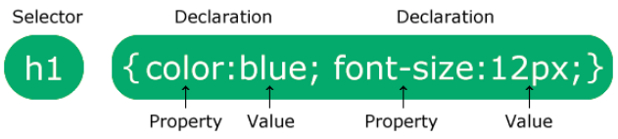.
- The selector points to the HTML element you want to style.
- The declaration block contains one or more declarations separated by semicolons.
- Each declaration includes a CSS property name and a value, separated by a colon.
- Multiple CSS declarations are separated with semicolons, and declaration blocks are surrounded by curly braces.
- Example: In this example all <p> elements will be center-aligned, with a red text color:
p {
color: red;
text-align: center;
}
p is a selector in CSS (it points to the HTML element you want to style: <p>).
color is a property, and red is the property value
text-align is a property, and center is the property value

Selector

Element Selector
The type selector is the simplest selector of all, and matches all occurrences of an element. In this example, all <p> tags throughout the document will have the following style applied, unless overridden.

p {color: #666;}

Universal Selector
The universal selector, used alone, matches all elements in the document tree, and thus will apply
styles to all elements. It is in effect a wildcard.
* {margin: 0; padding: 0;}
In this example, all tags are reset to have no padding or margin. This, by the way, is a practice to gain control over all the default padding and margin inherent in the way User Agents (UAs) display HTML.

Class Selector
The class selector matches a classname.

.largeFont {font-size: 1.5em;}
h3.cartHeader {text-align: center;}

The "largeFont" class will apply to all elements into which it is called. The "cartHeader" class will only function as styled if called into an H3 element. This is useful if you have another "cartHeader" declaration that you wish to override in the context of an H3 element, or if you wish to enforce the placement of this class.

ID Selector
The id selector uses the id attribute of an HTML element to select a specific element. The id of an element is unique within a page, so the id selector is used to select one unique element! To select an element with a specific id, write a hash (#) character, followed by the id of the element.
#para1 {
text-align: center;
color: red;
}

Descendant Selector
A selector can itself be a chain of one or more selectors, and is thus sometimes called a compound selector. In the example below, the white space between the H1 and EM elements is the descendant combinator. In other words, white space conveys a hierarchy. (If a comma were to have intervened instead, it would mean that we were styling H1 and EM elements alike.) Selectors using combinators are used for more precise drill-down to specific points within the document tree. In this example <em> tags will have the color red applied to them if they are within an <h1> tag.
h1 em {color: #F00;}
Three ways to add CSS in HTML document

- External Style Sheet − Define style sheet rules in a separate .css file and then include that file in your HTML document using HTML <link> tag.
- Internal Style Sheet − Define style sheet rules in the header section of the HTML document using <style> tag.
- Inline Style Sheet − Define style sheet rules directly along-with the HTML elements using style attribute.

External Style Sheet
If you need to use your style sheet to various pages, then it's always recommended to define a common style sheet in a separate file. A cascading style sheet file will have extension as .css and it will be included in HTML files using <link> tag.
Example

Consider we define a style sheet file style.css which has following rules −
.red {
color: red;
}
.thick {
font-size:20px;
}
.green {
color:green;
}
Here we defined three CSS rules which will be applicable to three different classes defined for the HTML tags. I suggest you should not bother about how these rules are being defined because you will learn them while studying CSS. Now let's make use of the above external CSS file in our following HTML document −
<!DOCTYPE html>
<html>
<head>
<title>HTML External CSS</title>
<link rel = "stylesheet" type = "text/css" href = "/html/ style.css">
</head>
<body>
<p class = "red">This is red</p>
<p class = "thick">This is thick</p>
<p class = "green">This is green</p>
<p class = "thick green">This is thick and green</p>
</body>
</html>
This will produce the following result −

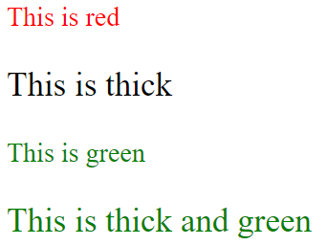
    - Internal Style Sheet
If you want to apply Style Sheet rules to a single document only, then you can include those rules in the header section of the HTML document using <style> tag.
Rules defined in the internal style sheet overrides the rules defined in an external CSS file.

Example

Let's re-write above example once again, but here we will write style sheet rules in the same HTML document using <style> tag −
<!DOCTYPE html>
<html>
<head>
<title>HTML Internal CSS</title>
<style type = "text/css">
.red {
color: red;
}
.thick{
font-size:20px;
}
.green {
color:green;
}
</style>
</head>
<body>
<p class = "red">This is red</p>
<p class = "thick">This is thick</p>
<p class = "green">This is green</p>
<p class = "thick green">This is thick and green</p>
</body>
</html>
This will produce the following result −

Inline Style Sheet
You can apply style sheet rules directly to any HTML element using the style attribute of the relevant tag. This should be done only when you are interested in making a particular change in any HTML element only.
Rules defined inline with the element overrides the rules defined in an external CSS file as well as the rules defined in <style> element.

Example
Let's rewrite the above example once again, but here we will write style sheet rules along with the HTML elements using the style attribute of those elements.
<!DOCTYPE html>
<html>
<head>
<title>HTML Inline CSS</title>
</head>
<body>
<p style = "color:red;">This is red</p>
<p style = "font-size:20px;">This is thick</p>
<p style = "color:green;">This is green</p>
<p style = "color:green;font-size:20px;">This is thick and green</p>
</body>
</html>
This will produce the following result −


  - Style rule cascading and inheritance
CSS are probably wondering what exactly cascades about cascading style sheets. In this section we look at the idea of cascading, and a related idea, that of inheritance. Both are important underlying concepts that you will need to grasp, and understand the difference between, in order to work properly with style sheets.

Rule Cascade
A single stylesheet associated with one or more web pages is valuable, but in quite a limited way. For small sites, the single style sheet is sufficient, but for larger sites, especially sites managed by more than one person (perhaps several teams who may never communicate) single style sheets don't provide the ability to share common styles, and extend these styles where necessary. This can be a significant limitation. Cascading style sheets are unlike the style sheets you might have worked with using word processors, because they can be linked together to create a hierarchy of related style sheets.

Font Family

The font family of a text is set with the font-family property. The font-family property should hold several font names as a "fallback" system. If the browser does not support the first font, it tries the next font. Start with the font you want, and end with a generic family, to let the browser pick a similar font in the generic family, if no other fonts are available.

Example

p{font-family:"Times New Roman", Times, serif;}

Font Style

The font-style property is mostly used to specify italic text. This property has three values:

- normal - The text is shown normally

- italic - The text is shown in italics

- oblique - The text is "leaning" (oblique is very similar to italic, but less supported)

Font Size

The font-size property sets the size of the text. Being able to manage the text size is important in web design. However, you should not use font size adjustments to make paragraphs look like headings, or headings look like paragraphs. Always use the proper HTML tags, like <h1> - <h6> for headings and <p> for paragraphs. The font-size value can be an absolute, or relative size.

Absolute size:
  - Sets the text to a specified size

  - Does not allow a user to change the text size in all browsers (bad for accessibility
reasons)

  - Absolute size is useful when the physical size of the output is known

Relative size:
  - Sets the size relative to surrounding elements

  - Allows a user to change the text size in browsers

The CSS Box Model

All HTML elements can be considered as boxes. In CSS, the term "box model" is used when talking about design and layout.
The CSS box model is essentially a box that wraps around HTML elements, and it consists of:

Margin - Clears an area around the border. The margin does not have a background color, it is completely transparent
Border - A border that goes around the padding and content. The border is affected by the background color of the box
Padding - Clears an area around the content. The padding is affected by the background color of the box
Content - The content of the box, where text and images appear
In order to set the width and height of an element correctly in all browsers, you need to know how the box model works.

CSS Background
CSS background properties are used to define the background effects of an element. CSS properties used for background effects:

Background Color
The background-color property specifies the background color of an element. The background color of a page is defined in the body selector.

Background Image

The background-image property specifies an image to use as the background of an element. By default, the image is repeated so it covers the entire element. The background image for a page can be set like this: Example
body {background-image:url('paper.gif');}
By default, the background-image property repeats an image both horizontally and vertically. Some images should be repeated only horizontally or vertically, or they will look strange, like this: Example
Body {background-image:url('gradient2.png');}
If the image is repeated only horizontally (repeat-x), the background will look better: Example

body{background-image:url('gradient2.png'); background- repeat:repeat-x;}
  - Text properties
CSS has a lot of properties for formatting text.

oText Color
oText Alignment
oText Decoration
oText Transformation
oText Spacing
oText Shadow

Text Color

- color: The color property is used to set the color of the text. The color is specified by: a color name - like "red",
a HEX value - like "#ff0000"
an RGB value - like "rgb(255,0,0)"
Look at CSS Color Values for a complete list of possible color values. The default text color for a page is defined in the body selector.

Example

body {
color: blue;
}
h1 {
color: green;
}

- background-color:
In this example, we define both the background-color property and the color property:
Example

body {
background-color: lightgrey; color: blue;
}
h1 {
background-color: black; color: white;
}
div {
background-color: blue; color: white;
}

Text Alignment
The text-align property is used to set the horizontal alignment of a text. A text can be left or right aligned, centered, or justified. The following example shows center aligned, and left and right aligned text (left alignment is default if text direction is left-to-right, and right alignment is default if text direction is right-to- left):
Example
h1 {
text-align: center;
}

h2 {
text-align: left;
}

h3 {
text-align: right;
}
When the text-align property is set to "justify", each line is stretched so that every line has equal width, and the left and right margins are straight (like in magazines and newspapers):
Example

div {
text-align: justify;
}

Text Align Last

The text-align-last property specifies how to align the last line of a text. Example
Align the last line of text in three <p> elements:

  - {
text-align-last: right;
}
  - {
text-align-last: center;
}
  - {
text-align-last: justify;
}

Text Direction

The direction and unicode-bidi properties can be used to change the text direction of an element:

Example

p {
direction: rtl;
unicode-bidi: bidi-override;
}

Vertical Alignment

The vertical-align property sets the vertical alignment of an element.

Example

img.a {
vertical-align: baseline;
}
img.b {
vertical-align: text-top;
}
img.c {
vertical-align: text-bottom;
}
img.d {
vertical-align: sub;
}
img.e {
vertical-align: super;
}

Text Decoration
The text-decoration property is used to set or remove decorations from text.
The value text-decoration: none; is often used to remove underlines from links:
Example
a {
text-decoration: none;
}
The other text-decoration values are used to decorate text:
Example

h2 {
text-decoration: overline;
}
h3 {
text-decoration: line-through;
}
h4 {
text-decoration: underline;
}

Text Transformation
The text-transform property is used to specify uppercase and lowercase letters in a text. It can be used to turn everything into uppercase or lowercase letters, or capitalize the first letter of each word:
Example
p.uppercase {
text-transform: uppercase;
}
p.lowercase {
text-transform: lowercase;
}
p.capitalize {
text-transform: capitalize;
}

Text Spacing

Text Indentation
The text-indent property is used to specify the indentation of the first line of a text:
Example
p {
text-indent: 50px;
}

Letter Spacing
The letter-spacing property is used to specify the space between the characters in a text.
The following example demonstrates how to increase or decrease the space between characters:
Example
h1 {
letter-spacing: 5px;
}
h2 {
letter-spacing: -2px;
}

Line Height
The line-height property is used to specify the space between lines:

Example

p.small {
line-height: 0.8;
}
p.big {
line-height: 1.8;
}

Word Spacing
The word-spacing property is used to specify the space between the words in a text. The following example demonstrates how to increase or decrease the space between words:
Example

p.one {
word-spacing: 10px;
}
p.two {
word-spacing: -2px;
}

White Space
The white-space property specifies how white-space inside an element is handled. This example demonstrates how to disable text wrapping inside an element:
Example
p {
white-space: nowrap;
}

Text Shadow
The text-shadow property adds shadow to text. In its simplest use, you only specify the horizontal shadow (2px) and the vertical shadow (2px):

Example h1 {
text-shadow: 2px 2px;
}

Next, add a color (red) to the shadow:
Example h1 {
text-shadow: 2px 2px red;

}

  - Bootstrap
- Bootstrap is the world's most famous free CSS framework.
- Bootstrap is a free front-end framework for faster and easier web development.
- Bootstrap includes HTML and CSS based design templates for typography, forms, buttons, tables, navigation, modals, image carousels and many others, as well as optional JavaScript plugins.
- Bootstrap also gives you the ability to easily create responsive designs

Responsive Web Design
Responsive web design is about creating web sites which automatically adjust themselves to look good on all devices, from small phones to large desktops.

Example

<div class="jumbotron text-center">
<h1>My First Bootstrap Page</h1>
<p>Resize this responsive page to see the effect!</p>
</div>

<div class="container">
<div class="row">
<div class="col-sm-4">
<h3>Column 1</h3>
<p>Lorem ipsum dolor..</p>
</div>
<div class="col-sm-4">
<h3>Column 2</h3>
<p>Lorem ipsum dolor..</p>
</div>
<div class="col-sm-4">
<h3>Column 3</h3>
<p>Lorem ipsum dolor..</p>
</div>
</div>
</div>

Advantages of Bootstrap:
- Easy to use: Anybody with just basic knowledge of HTML and CSS can start using Bootstrap

- Responsive features: Bootstrap's responsive CSS adjusts to phones, tablets, and desktops

- Mobile-first approach: In Bootstrap, mobile-first styles are part of the core framework

- Browser compatibility: Bootstrap 4 is compatible with all modern browsers (Chrome, Firefox, Internet Explorer 10+, Edge, Safari, and Opera)

Installation
There are two ways to start using Bootstrap 4 on your own website.
a.Include Bootstrap 4 from a CDN
b.Download Bootstrap 4 from getbootstrap.com
If you don't want to download and host Bootstrap 4 yourself, you can include it from a CDN (Content Delivery Network). jsDelivr provides CDN support for Bootstrap's CSS and JavaScript. You must also include jQuery:

<!-- Latest compiled and minified CSS -->
<link rel="stylesheet" href="https://cdn.jsdelivr.net/npm/ bootstrap@4.6.1/dist/css/bootstrap.min.css">

<!-- jQuery library -->
<script src="https://cdn.jsdelivr.net/npm/jquery@3.5.1/dist/ jquery.slim.min.js"></script>

<!-- Popper JS -->
<script src="https://cdn.jsdelivr.net/npm/popper.js@1.16.1/dist/ umd/popper.min.js"></script>

<!-- Latest compiled JavaScript -->
<script src="https://cdn.jsdelivr.net/npm/bootstrap@4.6.1/dist/ js/bootstrap.bundle.min.js"></script>

Create First Web Page with Bootstrap 4

Add the HTML5 doctype

Bootstrap 4 uses HTML elements and CSS properties that require the HTML5 doctype. Always include the HTML5 doctype at the beginning of the page, along with the lang attribute and the correct character set:
<!DOCTYPE html>
<html lang="en">
<head>
<meta charset="utf-8">
</head>
</html>

Bootstrap 4 is mobile-first

Bootstrap 4 is designed to be responsive to mobile devices. Mobile-first styles are part of the core framework.
To ensure proper rendering and touch zooming, add the following <meta> tag inside the
<head> element:
<meta name="viewport" content="width=device-width, initial-scale=1">

The width=device-width part sets the width of the page to follow the screen-width of the device (which will vary depending on the device).
The initial-scale=1 part sets the initial zoom level when the page is first loaded by the browser.

Containers
Bootstrap 4 also requires a containing element to wrap site contents. There are two container classes to choose from:
- The .container class provides a responsive fixed width container
- The .container-fluid class provides a full width container, spanning the entire width of the viewport The following example shows the code for a basic Bootstrap 4 page (with a responsive fixed width container):

<!DOCTYPE html>
<html lang="en">
<head>
<title>Bootstrap Example</title>
<meta charset="utf-8">
<meta name="viewport" content="width=device-width, initial-scale=1">
<link rel="stylesheet" href="https://cdn.jsdelivr.net/npm/bootstrap@4.6.2/dist/css/bootstrap.min.css" >
<script src="https://cdn.jsdelivr.net/npm/jquery@3.7.1/dist/jquery.slim.min.js"></script>
<script src="https://cdn.jsdelivr.net/npm/popper.js@1.16.1/dist/umd/popper.min.js"></script>
<script src="https://cdn.jsdelivr.net/npm/bootstrap@4.6.2/dist/js/bootstrap.bundle.min.js"></script>
</head>
<body>
<div class="container">
<h1>My First Bootstrap Page</h1>
<p>This part is inside a .container class.</p>
<p>The .container class provides a responsive fixed width container.</p>
</div>
</body>
</html>

Output

